**C Style String in C++**

In C, strings are defined as an array of characters. The difference between a character array and a string is the string is terminated with a special character ‘\0’. In C, the string is actually represented as an array of characters terminated by a null string. Therefore the size of the character array is always one more than that of the number of characters in the actual string. This thing continues to be supported in C++ too. The C++ compiler automatically sets “\0” at the end of the string, during initialization of the array.

**Initializing a String in C++:**

1. char str[] = "Geeks";

2. char str[6] = "Geeks";

3. char str[] = {'G', 'e', 'e', 'k', 's', '\0'};

4. char str[6] = {'G', 'e', 'e', 'k', 's', '\0'};

Below is the memory representation of a string “Geeks” in C++.  
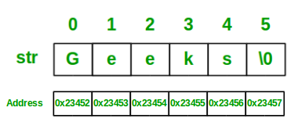

Let’s look at some examples to better understand the string representation in C++, using C style:

C++

// C++ program to demonstrate

// Strings using C style

#include <iostream>

using namespace std;

int main()

{

// Declare and initialize string

char str[] = "Geeks";

// Print string

cout << str;

return 0;

}

**Output**

Geeks